Predatory Journals: Do Not Enter

Faizan Khan BSc^{1, 2}, David Moher PhD^{1, 2}

- School of Epidemiology, Public Health and Preventive Medicine, University of Ottawa
- Clinical Epidemiology Program, Ottawa Hospital Research Institute

Abstract word count: 107

Manuscript word count: 1,399

Abstract
The escalation in open-access publishing has fueled the rise of questionable businesses, namely, ‘predatory’ journals. Predatory journals and their publishers seek manuscripts through aggressive electronic solicitation andexecute flawed peer-review practices, consequently undermining the scholarly record and undermining current research cultures, globally. As these journals are not indexed in any legitimate databases, the research they publish is often undiscoverable and fails to be disseminated to a worldwide readership.. Acknowledging this threat to the credibility of science, This article aims to alert researchers at various levels of their career, of the uprising global issue of predatory journals, and offer helpful advice and resources for identifying and avoiding them.
Introduction
Researchers and trainees (e.g. undergraduate, graduate, medical and post-doctoral) publish their work for various reasons including sharing knowledge with colleagues, hoping to affect healthcare practice and/or policy, and likely to help further their training and career opportunities. One reason that makes publishing imperative is centred on the concept of “publish or perish”, referring to the pressure in academia to expeditiously and persistently publish in order to maintain or advance one’s career. Nevertheless, researchers trying to publish their work are often left with difficult realities. They need to be as productive as possible and ensure their research is published in journals with the highest possible impact factor. Yet, successfully passing the rigor of peer review poses a significant barrier to publishing; many journals have low acceptance rates..
In efforts to reduce the barriers to publishing, some journals (including several student–run academic ones) actively pursue prospective authors by sending an electronic invitation or a “Call for Submissions” to their distribution list, seeking manuscripts for a specific thematic journal issue or series. However, potentially questionable businesses, posing as legitimate publishers and hence labelled ‘predatory’, have set up illegitimate, online, (supposedly) open-access journals (the contents of many of these journals are not open access).

What are predatory journals?
Predatory journals are vaguely defined. These publications can perhaps be best characterized by attributes, behaviors and practices outlined in Table 1. Unlike legitimate journals, they now routinely, persistently, and intrusively invite researchers and trainees to submit manuscripts to their journals. They typically populate their distribution lists as a result of scouring the Internet. In contrast to legitimate journals, predatory journals offer to promptly publish anything without providing robust if any peer-review [1, 2].
Jeffery Beall, a librarian at the University of Colorado, coined the term ‘predatory journal’ [3] and reports that the number of predatory publishers has risen from 18 in 2011 to nearly 930 in 2016 [4]. Unfortunately, authors have published nearly 500,000 articles in 10,000 predatory journals [5]. While sometimes publicly accessible via Internet searches of the specific journal or publisher, these publications are not indexed in reputable library systems (e.g., PubMed) and are undiscoverable through the standard searches. As such, the articles published in these journals are not disseminated, read and used by anyone.. These journal editors and their publishers are contemptuous, defy normative behavior, and are unethical in their actions. Unless stopped immediately, predatory journals will continue to have the potential to permanently degenerate the morality of scientific publishing and the communication of science. Furthermore, the synergistic effect of the temptation of researchers to publish quickly and easily in response to the academic pressures and the rigor of legitimate peer-review, combined with the unethical publishing practices of predatory journals can result in harm to health-information-seeking patients and the general public, worldwide.[1, 2].

Why do predatory journals exist?
It is unclear why predatory journals exist. At some level, they are responding to unmet needs of prospective authors. Researchers and trainees working in fiscally constrained parts of the world cannot afford the current, and expensive, author processing charges (i.e. publication fee; although some legitimate open access journals have waivers particularly for trainees). Legitimate peer review is not only rigorous but often takes a long time to complete. Prospective authors might be enticed by the promise of almost immediate publication, particularly if these publications can be converted into training and career currency. These journals may also exist because the charlatans operating them are interested in any way to make money feigning interest in the scientific process.

How can researchers and students identify predatory journals/publishers?
Predatory journals and publishers are difficult to identify. Unfortunately, predatory publishing is often confused with open access publishing, which has widely benefited scientific communication; as such, distinguishing between genuine and predatory open access publishers is a challenge for many.
One of the first recommended actions is to search for the journal/publisher’s name on “Beall’s lists of predatory publishers” . There are two lists categorized into publishers of single journals [6] and publishers of multiple journals [7]Submission of manuscripts to any publisher or journal on these lists should be avoided. Although these lists are imperfect, as the selection of publishers and their journals are not double-checked by an independent source, they offer a good starting point for prospective authors trying to identify questionable journals.
Additionally, researchers may refer to the “Think-Check-Submit” initiative (http://thinkchecksubmit.org/) [10], which is a campaign established to help researchers identify trusted journals. This campaign has been produced through the support of various scholarly, reputable organizations in response to predatory publishing. For example, to help decide whether one should submit their work to a particular journal, the campaign offers a checklist consisting of various questions such as:
- Does the publisher belong to a well-recognized industry initiative such as the Committee on Publication Ethics (COPE)?
- If the journal is open access, is it listed is the Directory of Open Access Journals (DOAJ)?
- If the Journal is open access, does the publisher belong to the Open Access Scholarly Publishers’ Association (OASPA)?
The Ottawa Hospital Research Institute’s Centre for Journalology in partnership with the University of Ottawa’s Faculty of Medicine has developed resources to help the research community, including trainees, avoid submission to predatory journals (see Table 2). If trainees still have questions about predatory journals, they can consult with the Centre’s publication officer [11] (see Table 2). Students and junior researchers are particularly encouraged to consult with their supervisors, mentors, and other senior students/members within their research group, before responding to any invitations from potentially predatory journals/publishers.
Our guidance is focused exclusively on helping researchers and students avoid submitting manuscripts to predatory journals. Regrettably, a new phenomenon, namely, predatory conferences, is emerging. Predatory conferences rarely exist in reality; it is another illegitimate scheme in the armamentarium of predatory journal publishers. All of the guidance provided about avoiding predatory journals can also be used to help avoid submitting abstracts to the meetings, avoiding conference registration fees and travel and accommodation costs to attend such meetings.

What actions can be taken to stopping predatory journals?
Stopping predatory journals and preventing researchers from submitting to them requires a collaborative effort. First and foremost, it is of crucial importance for prospective authors, especially those in training and those early in their careers, to be aware of the hazards of predatory journals and evaluate the merits of submitting any manuscript to them with extreme caution. This awareness can be facilitated through the united action of reputable publishers, editors, working together with academic institutions and research funding agencies to develop educational outreach, including online Webinars on how to avoid publishing in these journals [1, 2].
As noted above, the most dominant attribute of predatory journals is the persistent electronic invitations to submit manuscripts on research topics pertinent to the expertise of the invitee. A previous evaluation of invitations from predatory journals [12] found that all these invites can be deleted, and the journal/publisher’s websites can be added to personal/institutional e-mail filters and therefore be blocked.
Furthermore, many invitations have a journal unsubscribe link and invitees ought to consider unsubscribing before deleting the invitation. Additionally, researchers may ask their institutions to add the publisher’s Uniform Resource Identifier link to the current ‘black list’ that many institutions already maintain.
More useful resources available to researchers regarding predatory journals are outlined in Table 2.

Conclusion
Although no standard definition exists for predatory journals, they are best described as journals that recruit authors through high volumes of daily electronic invites, exploit open-access, and offer to publish anything quickly without any peer-review. As such, predatory journals demoralize scholarly publishing; corrupt the exchange of scientific knowledge; and ultimately pollute the evidence needed for improving global health. Due to the current ‘publish or perish’ paradigm, researchers early in their careers may be of the most susceptible to invitations from predatory journals and the harms of publishing in them. Because these journals are not indexed in reputable databases, publications in these journals are unlikely to be an effective way to share research knowledge with colleagues, or to influence healthcare practice and/or policy. Therefore, researchers and trainees at all levels are urged to exercise caution, think before they submit, and advise others to do not enter the hazardous world of predatory publishers and their journals. Future research aimed at understanding why authors publish in these journals is needed. Such knowledge will help develop programs to prevent submissions to predatory journals.

References
- Moher D, Moher E. Stop predatory publishers now: Act collaboratively. Ann Intern Med. 2016;164 (9):616-617
- Clark J, Smith R. Firm action needed on predatory journals. BMJ. 2015; 350:h210.
- Beall J. Predatory publishers are corrupting open access. Nature. 2012; 489:179.
- Beall J. “Beall’s list of predatory publishers” https://scholarlyoa.com/2016/01/05/bealls-list-of-predatory-publishers-2016/ . (Accessed July 9, 2016)
- Shen C, Bjork BC. ‘Predatory’ open access: a longitudinal study of article volumes and market characteristics. BMC Med. 2015;13:230.
- Beall’s List of Standalone Journals. https://scholarlyoa.com/2016/01/05/bealls-list-of-predatory-publishers-2016/. (Accessed September 4, 2016)
- Beall’s List of Publishers. https://scholarlyoa.com/publishers/. (Accessed September 4, 2016
- https://www.theguardian.com/australia-news/2014/nov/25/journal-accepts-paper-requesting-removal-from-mailing-list (Accessed July 9, 2016).
- Xia J, Harmon JL, Connolly KG, Donnelly RM, Anderson MR, Howard HA. Who publishers in “predatory” journals? J Assoc Inf Sci Technol. 2015;66:1406–17
- “Think, Check, Submit” Initiative. http://thinkchecksubmit.org. (Accessed July 9, 2016).
- Cobey KD, Galipeau J, Shamseer L, Moher D. Report on a pilot project to introduce a publications officer. CMAJ. 2016; doi:10.1503/cmaj.151340
- Moher D, Srivastava A. You are invited to submit... BMC Med. 2015;13:180

Figure 1. Example of an electronic invitation and its features from a potential predatory journal.
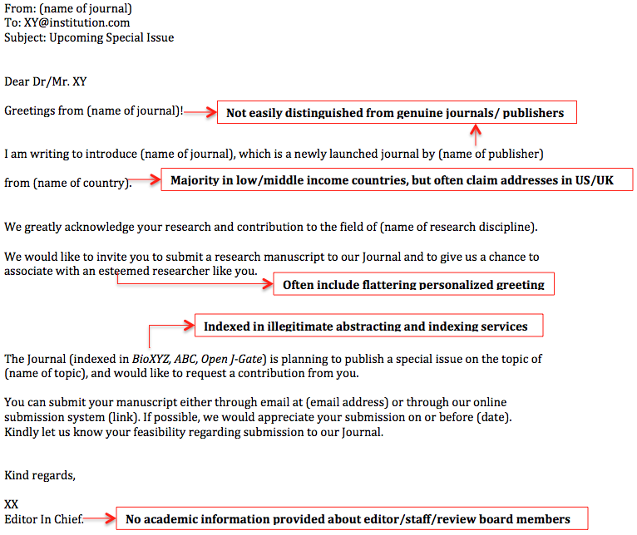

Table 1: Attributes, characteristics and practices of potential predatory journals.
Daily invitation emails in frustratingly high volumes (see Figure 1 for email and its features).
Unrealistic promises of rapid peer-review and publication.
Most either do not send manuscripts for peer-review and publish them “as is”, or provide nonsense
feedback.
The infamous incident is of a manuscript submitted to the International Journal of Advanced Computer Technology which was a repetition of a 7-word sentence “Get me off your f***ing e-mail list”. The paper was "peer-reviewed", judged as excellent and published [8].
Most are in low and middle-income countries (particularly Asia), but often use addresses in the United States and United Kingdom [9].
Intentionally try to confuse prospective authors by creating journal and publisher names/logos extremely similar to legitimate established ones.
Often claim to have Impact Factors although almost always these are fictitious.
Offer low Author Processing Charges (APCs, i.e. publication fee) because they run sham businesses that have no costs.
Provide no academic information (e.g. institutional affiliation) about editors, staff or review board members.
Either falsely claim to be indexed, or are not indexed in any legitimate electronic databases, such as PubMed or MEDLINE.

Table 2: Publication Resources for Researchers
Dr. Kelly Cobey, a publications officer [11], based at the Centre for Journalology, Ottawa Hospital Research Institute, can be consulted (kcobey@toh.on.ca) by researchers for a variety of topics on publishing, including concerns about predatory journals.

The Centre for Journalology (i.e., science of publication practices) has been established at the Ottawa Hospital Research Institute. Researchers can access their website (http://www.ohri.ca/journalology). It includes a ‘Resources’ section, which contains information about predatory journals ((http://www.ohri.ca/journalology/resources.aspx).

The Centre for Journalology also has a growing research portfolio regarding predatory journals. Interested readers can contact Ms. Larissa Shamseer (lshamseer@ohri.ca).

