**[Prison as a Space to Heal: Women Federal Prisoners in Canada and the Role of the Healthcare Professional]**

Abstract word count: [114 words]

Manuscript word count: [1993 words]

**Abstract**

Women incarcerated in federal prisons are a small but growing proportion of Canada’s penal institutions and have needs, challenges, and health issues vastly different than those of male inmates. Women that come into conflict with the law often have experienced sexual abuse, utilize drugs and alcohol, and have poor health. Healthcare professionals in prison should be aware of these health markers and the associated difficulties of treating patients in prison. This article aims to to catalyze conversation and further inquiry into the potential role of the carceral reality as a healing space, and the health professionals within it as healers.

**A Note to the Reader**

It is not often that the health of a prisoner is considered as a point of concern. Most often, discussions surrounding criminals involve themes such as culpability, justice, and punishment. However, this commentary adopts a different point of view—that is concerned with the health status of prisoners, and particularly women incarcerated in Canada’s federal prisons. Before we launch into a discussion of healthcare in prison, I would like to emphasize that the priorities of Correctional Service Canada (CSC), the federal prison government agency, include managing criminals for public safety, administering mental health interventions, as well as rehabilitating criminal behavior for future integration into the community [1].

While providing general healthcare may not be the primary concern of prison, an unavoidable reality is that most prisoners have a low health status at time of incarceration, and it is the responsibility of the prison authorities to address any health issues. Indeed, the 1992 Corrections and Conditional Release Act states that the CSC is responsible for providing “every inmate with essential health care and access to non-essential mental health care that will contribute to the inmate’s rehabilitation and successful reintegration in the community,” [2]. Notwithstanding the CSC’s official stance on the care of prisoners, an institution’s bureaucracy together with possibly negative attitudes of healthcare professionals towards prisoners bring forth and push forward obstacles to achieving better health. In fact, the notion of “less eligibility” refers to the general assumption that prisoners have lesser rights to sufficient, good quality care than the rest of the population because they broke the law [3]. As future and current healthcare professionals, it is our responsibility to ensure we are aware of the hardships experienced by prisoners, the importance of advancing prisoner health, and our own biases towards prisoners, in order to better serve these communities in a more empathetic and effective way.

**Why Federal Women Prisoners?**

Although women represent a smaller proportion of Canada’s prisoners, their numbers are growing. Between 2006 and 2016, the number of women in federal prisons has increased 35% from 502 to 680 women [4]. Moreover, even though they make up only about 5% of the Canadian population, 36% of women inmates are Aboriginal [4]. As a population that is both quantitatively and qualitatively different than its male counterpart, it is important to consider women prisoners separately from men. This must be done in order to better understand their demographics, challenges, and how these apply to healthcare and medicine.

Women face different health issues in prison than their male counterparts, with their incarceration further complicated by reproductive health concerns, maternal responsibilities to children outside of prison, and pregnancy in prison. In addition, one of the most salient points of difference between male and female prisoners is the prevalence of infectious diseases [5]. HIV is rampant in prisons, with a prevalence of 1.65% among men compared to 3.35% among women, and with Indigenous women carrying a heavier burden than non-Indigenous women as is seen on figure 1 [6]. A significantly larger proportion of federally sentenced women than men have a psychotropic medication prescription—45.7% for women compared to 29.6% for men [4]. Clearly, women in prison experience a disproportionate burden of issues relating to familial obligations, medical problems that may include infectious diseases, and mental health illnesses.

The choice to focus on federally-incarcerated women was driven by the fact that the federal prison system presents a unique situation, different from provincial jails, where a prisoner is sentenced for a minimum of two years. This prolonged institutionalization poses a more significant effect on the imprisoned person, since she is subject to the social dynamics, negotiations of power, constraints, and allowances afforded by the prison environment. In the context of healthcare, federal prisons also have a greater potential to effect change in the prisoner’s health status and lifestyle behaviors. While in prison, government institutions may have the opportunity to comprehensively treat chronic medical, social, and mental problems that often are not addressed in short-term institutions [7]. As expressed by Dominique Robert, a researcher from the University of Ottawa, and her colleagues, “for some women, incarceration becomes a time to reconstruct themselves, physically and mentally through access to healthcare, though limited,” [5].

**A Profile of Women Prisoners**

A large proportion of women are of child-bearing age at time of incarceration, with the median age for both men and women prisoners being 33 in 2014-2015 [8]. That being said, in keeping with international patterns, the incarcerated population age in Canada is increasing, as can be seen in Figure 2 [4, 8]. Importantly, women in prison tend to have a similar health and social profile before being incarcerated—a history of sexual abuse, mental health issues, early drug and alcohol use, and poor nutrition and health status are commonly found in these women [5]. Indeed, between 50%-80% of federally imprisoned women have experienced some sort of abuse before being incarcerated [9]. Moreover, the type of offences that lead to the incarceration of women may be related to their profile at the time of imprisonment. Women’s pathways to crime are often linked with a history of early childhood victimization, re-victimization at the hands of an intimate partner later in life, and subsequent coping strategies such as running away or drug and alcohol abuse that may increase a woman’s risk of being in conflict with the law [10]. In fact, according to the 2015 Public Safety Canada data, 56% of women offenders are incarcerated for a violent offence, and 26% are serving time for a serious drug offence [8].

As for the health status of women prisoners, the most prevalent health conditions reported by women offenders are back pain, hepatitis C, and asthma [11]. This is combined with the fact that more than 50% of incarcerated women have a mental illness, compared to 26% of male prisoners [4]. This may explain the widespread perception among the public that there is an unacceptably high utilization of health services by prisoners compared to the general public. Indeed, data suggest that prisoners visit a physician 6.7 times annually—a rate that is around 2.4 times higher than the annual rate for the general population [5, 13-14]. In addition, women tend to use health services more often than men [5]. However, this over-utilization of health services may be accounted for by the women’s poor health at the time of incarceration as well as by the exacerbation of health problems due to the prison environment—rampant infectious diseases, lack of control, and the ensuing stress—which may all contribute to deteriorating health once in prison [5].

**The Healthcare Professional’s Role in Prison**

The healthcare professional working in a prison must contend with near-certain role duplication: care and punishment [5]. In a typical healthcare setting, the responsibility of a doctor or a nurse is to care for the patient; however, the role of a healthcare professional is complicated by the carceral reality, where principles such as patient autonomy may be nullified by the fact that the patient is also a prisoner who is not able to choose or move freely. Similarly, since prison authorities are ultimately responsible for the prisoner’s rehabilitation, the institution’s involvement may hinder the patient-doctor relationship. In a recent report by the Correctional Investigator Canada, it has been noted that the increasing involvement of healthcare professionals in Segregation Review Boards, where a decision is made about putting a particular prisoner in segregation, often presents ethical dilemmas in the professional’s provision of therapeutic care for that patient [4]. In these contexts, the healthcare professional is expected to provide details about a patient’s mental state, and thus the professional’s allegiance is not wholly to the patient, but also to the institution. Hence, it is often the case that health professionals must also act as punishers.

One can further understand the difficulties associated with the patient-doctor relationship in prison by considering the secrecy of prison culture that is associated with drug smuggling into prison [5]. In her article Penny Mellor, an ex-prisoner from the U.K., revealed appalling ways in which drugs may be brought into the prison: “‘Decrutching’… is the term used when a prisoner comes in with drugs secreted in her vagina and other inmates pin her down and remove those drugs with any available tool,” [14]. The difficulty in these situations is that despite serious injuries, the assaulted woman likely will not report her injuries or go to the doctor for fear of being punished for supplying the drugs. Thus a prisoner’s suspicion of the institution includes suspicion in the healthcare professional, who is practicing within the boundaries of the penal environment.

In a setting where the distinction between a healthcare professional and a prison warden is thin, the patient-professional relationship may be formed on a weak foundation. This is why the Correctional Investigator Canada recommended in his most recent annual report that the CSC’s “operational policies do not conflict with or undermine the standards, autonomy, and ethics of professional health care workers in corrections” [4]. The goal of this recommendation is to limit the role confusion experienced by health care workers when they treat their incarcerated patients.

The biggest challenge in providing care for prisoners may be maintaining the empathy and impartiality necessary to treat the prisoners as patients who require medical help, and not as criminals. Dr. Price, a Manitoba doctor working in provincial prisons, illustrates this point: “I have to constantly remind myself they are patients and treat them with respect. I make it a point to not know what the patient has done and what they have been incarcerated for,” [15]. On the other hand, it is important to be aware of the prison culture, and be cognizant that some inmates will try to manipulate a healthcare professional to get drugs—either to use or to sell—or simply want to go to the hospital to break the monotony and tension of prison [5]. Notwithstanding, medical professionals must be careful of the approach with which they treat prisoners. Prisoners, just like any other patient, can perceive a lack of empathy or derisive attitudes from their doctor or nurse. The negative demeanor of the health professional may impede the prisoners from sharing psychological distress and mental health concerns [16].

Despite the pressure and hardships associated with working in a prison, the work of a healthcare professional behind bars can be very gratifying as they see the positive changes incurred in a prisoner over time. As previously mentioned, incarceration for some women can represent a break from their chaotic lifestyles that are replete with drug and alcohol use, domestic violence, and homelessness, and invoke an opportunity for them to invest in their health and turn their lives around [7]. Healthcare professionals can play a pivotal part in women prisoners’ transformations. Perhaps the most significant realm where health professionals can have far-reaching influence is elucidated in Robert’s vision of adequate medical care: “the clinical space becomes a space for validation where women feel they can be themselves, and be listened to and learn about who they are,” [5].

**Conclusion**

Federal prisons present a special dilemma as well as a potential solution. While provincial incarceration periods go up to two years, federal prisoners are institutionalized for longer . Although the prison environment can potentially exacerbate prisoners’ health problems, and the prison experience can be isolating and harrowing, it cannot be ignored that prisons have a mandate to provide healthcare for their prisoners, and that prisoners can take the opportunity to finally ameliorate their often-neglected health conditions. This is especially true for female prisoners, who generally enter prisons with a history of sexual abuse, drug and alcohol use, and very poor health status. Notwithstanding the need to be aware of the prison culture and be apprehensive of possible risks and ethical dilemmas, healthcare professionals who hope to care for women in prison should strive to treat incarcerated prisoners with the same integrity, attention, and respect that their non-institutionalized patients receive.

1. Correctional Service Canada. Our Priorities [Internet]. Ottawa (ON): Correctional Service Canada; 2016 May 13 [cited 2017 October 7]. Available from: [http://www.csc-scc.gc.ca/about-us/006-0002-eng.shtml#](http://www.csc-scc.gc.ca/about-us/006-0002-eng.shtml)
2. Correctional Service Canada. Health Services [Internet]. Ottawa (ON): Correctional Service Canada; 2017 March 23 [cited 2017 October 7]. Available from <http://www.csc-scc.gc.ca/health/index-eng.shtml>
3. Vaughn MS. Penal harm medicine: State tort remedies for delaying and denying health care to prisoners. Crime, Law and Social Change. 1999;31(4):273-302.
4. Sapers H. Annual Report of the Office of the Correctional Investigator 2015-2016. Ottawa (ON): The Correctional Investigator Canada; 2016 June. 92 p. Report No.: 43
5. Robert D, Frigon S, Belzile R. Women, the embodiment of health and carceral space. Int J Prison Health. 2007;3(3):176-188.
6. Correctional Service Canada. Human Immunodeficiency Virus (HIV) Age, Gender and Indigenous Ancestry. 2016. <http://www.csc-scc.gc.ca/publications/005007-3034-eng.shtml>
7. Ahmed R, Angel C, Martel R, Pyne D, Keenan L. Access to healthcare services during incarceration among female inmates. Int J Prison Health. 2016;12(4):204-215.
8. Public Safety Canada Portfolio Corrections Statistics Committee. 2015 Corrections and Conditional Release Statistical Overview. Ottawa (ON): Public Safety Canada; 2016. 149 p. Cat. No.: PS1-3E-PDF
9. Laishes J. The 2002 Mental Health Strategy for Women Offenders [Internet]. Ottawa (ON): Correctional Service Canada; 2002 [updated 2013 Dec 6; cited 2017 Oct 6]. Available from: <http://www.csc-scc.gc.ca/publications/fsw/mhealth/toc-eng.shtml>
10. Pollack S, Kerry B. Negotiating contradictions: Sexual abuse counseling with imprisoned women. Women & Therapy. 2007; 29(3-4): 117-133.
11. Nolan A, Stewart L. Self-Reported Physical Health Status of Incoming Federally-Sentenced Women Offenders: Comparison to Men Offenders. Ottawa (ON): Correctional Service Canada; 2014. 1 p. Report No.: ERR-14-5
12. Sheps SB, Schechter MT, Prefontaine RG. Prison health services: a utilization study. J Community Health. 1987;12(1)4-22.
13. Kouyoumdjian F, Schuler A, Matheson FI, Hwang SW. Health status of prisoners in Canada. Canadian Family Physician. 2016;62(March):215-222.
14. Mellor P.A. The inside story on prison health care. British Medical J. 2003;324(7379):59.
15. Larocque C. Doctors behind bars. Medical Post (Chicago Ed.). 2004 Oct 12:Sect. Features. 40:38
16. Birmingham L, Gray J, Mason D, Grubin D. Mental illness at reception into prison. Crim. Behav. Ment. Health. 2000;10(2):77-87.

**Figures**

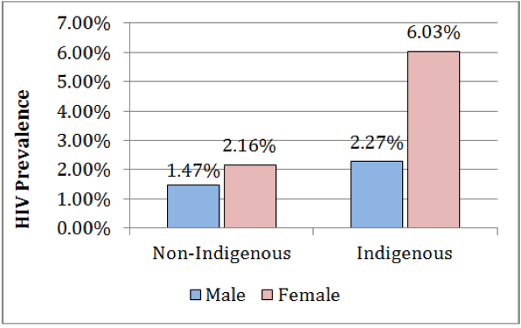

**Figure 1.** HIV Prevalence by Indigenous Ancestry and Gender. Taken from the Correctional Services of Canada *Human Immunodeficiency Virus (HIV) Age, Gender and Indigenous Ancestry*.

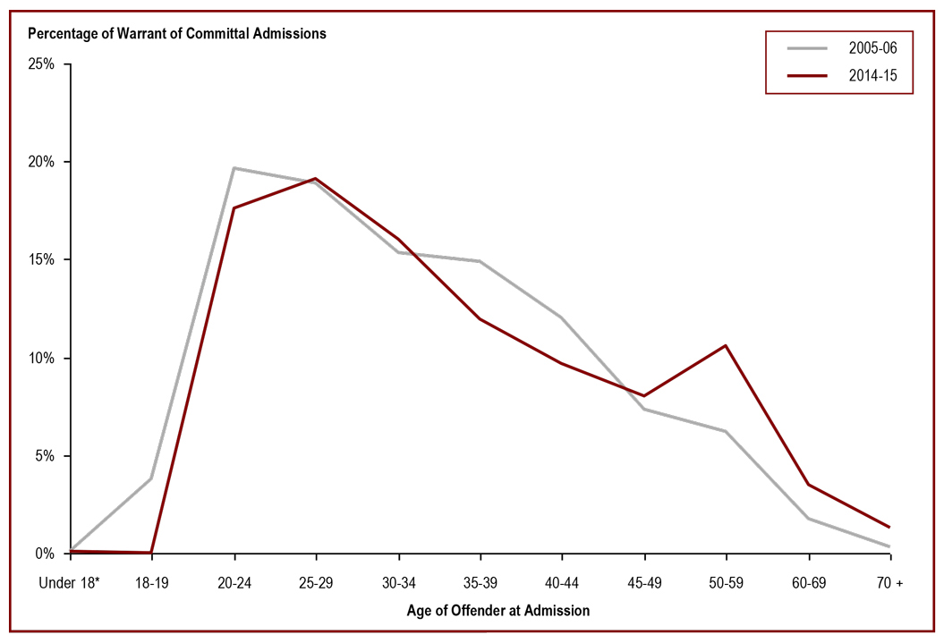

**Figure 2.** Age of Offender at Admission: Comparison between 2005-2006 and 2014-2015. Taken from Public Safety Canada *2015 Corrections and Conditional Release Statistical Overview.* Data source: Correctional Service Canada.