Supplement 1. Scenario Vignette Given to Members of Both Groups as a Simulated “Patch Call” for Impending Patient Arrival.

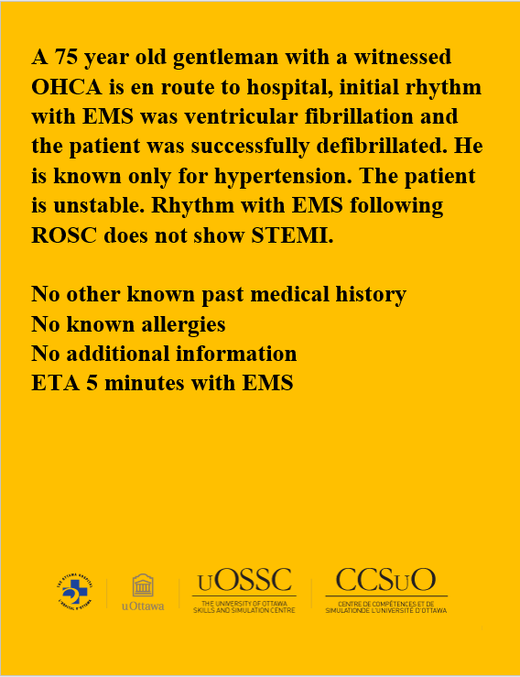
OHCA is out of hospital cardiac arrest; EMS is Emergency Medical Services; ROSC is return of spontaneous Circulation; STEMI is ST elevation myocardial infarction; ETA is Estimated time of Arrival.

Supplement 2. Intervention Checklist

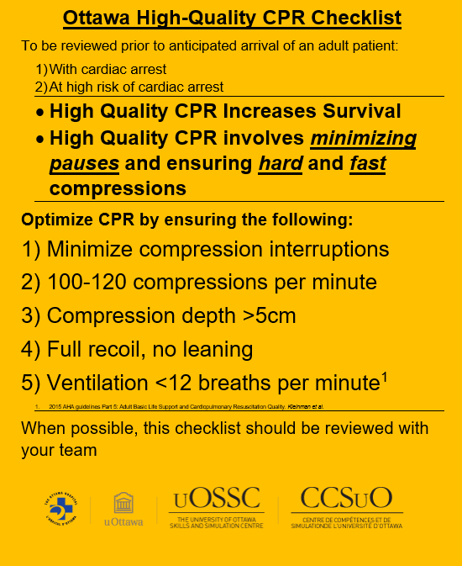

Supplement 3. Diagram and Brief Description to Illustrate Case Flow

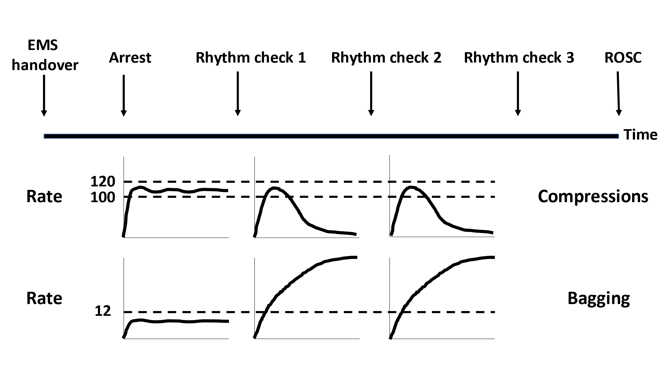

Shortly after EMS handover, the patient’s hemodynamics deteriorate, and they abruptly arrest.

Following the patient re-arresting, ACLS would commence adhering to usual parameters. After the first cycle of CPR, the quality of compressions and bag-mask ventilation (BMV) deteriorated in a standardized-rehearsed manner at predefined times, until poor quality was recognized and corrected by the participant. CPR quality would deteriorate until intervened upon, as illustrated above.

Only parameters commented on would be modified. Additionally, CPR quality deterioration would re-occur in the third cycle of CPR, regardless of if it was corrected in the second.

Supplement 4. Study Exit Survey for Control Participants

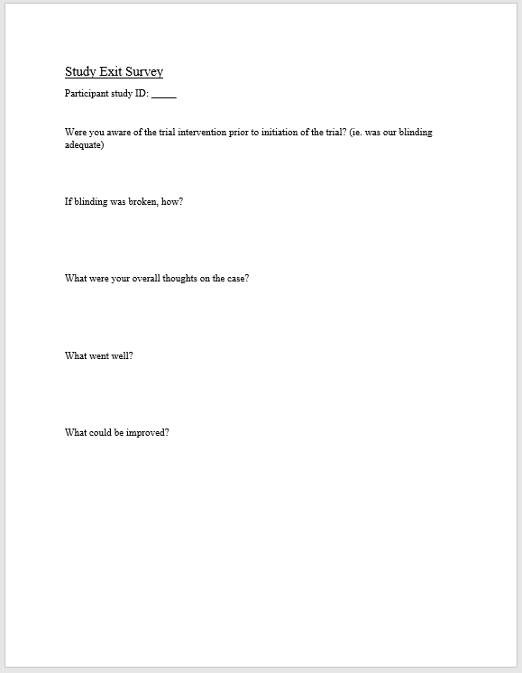

Supplement 5. Study Exit Survey for Intervention Participants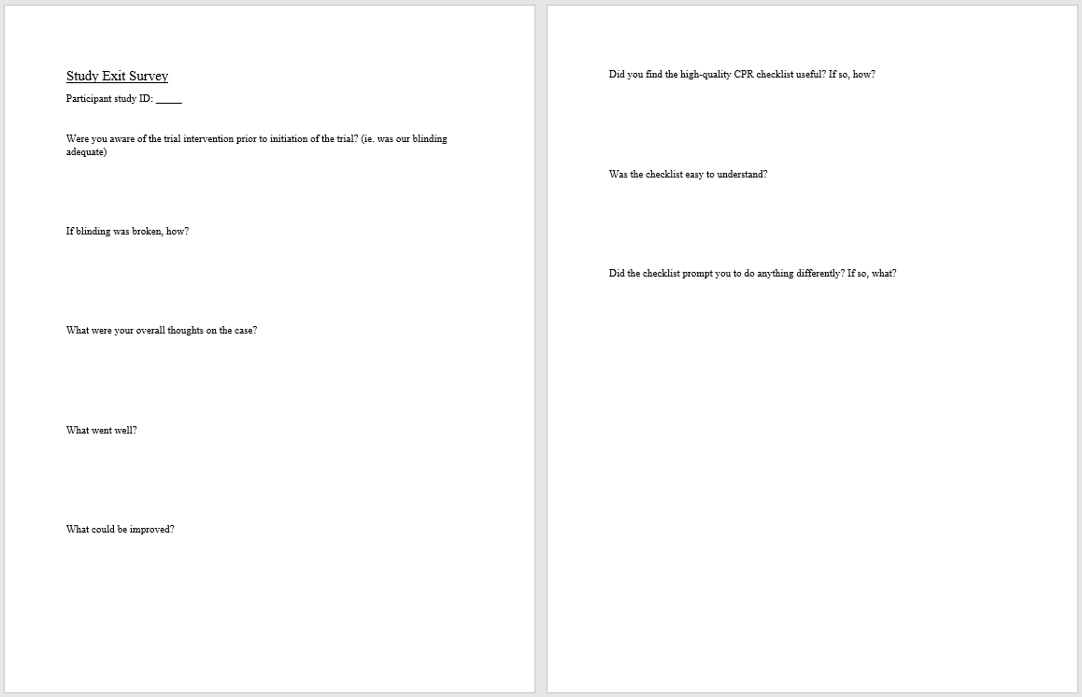Supplement 6: Participant Enrollment Form

