Supplementary material
Appendix 1: CONSORT 2010 checklist of information to include when reporting a randomised trial.
A pilot randomized controlled trial of anatomy coloring books for first-year medical students: Impact on anxiety and anatomical knowledge retention



Section/Topic | Item No | Checklist item | Reported on page No
Title and abstract
 | 1a | Identification as a randomised trial in the title | 1
 | 1b | Structured summary of trial design, methods, results, and conclusions (for specific guidance see CONSORT for abstracts) | 1
Introduction
Background and objectives | 2a | Scientific background and explanation of rationale | 2-3
Background and objectives | 2b | Specific objectives or hypotheses | 3
Methods
Trial design | 3a | Description of trial design (such as parallel, factorial) including allocation ratio | 3
Trial design | 3b | Important changes to methods after trial commencement (such as eligibility criteria), with reasons | N/A
Participants | 4a | Eligibility criteria for participants | 3
Participants | 4b | Settings and locations where the data were collected | 3
Interventions | 5 | The interventions for each group with sufficient details to allow replication, including how and when they were actually administered | 4-5
Outcomes | 6a | Completely defined pre-specified primary and secondary outcome measures, including how and when they were assessed | 4
Outcomes | 6b | Any changes to trial outcomes after the trial commenced, with reasons | N/A
Sample size | 7a | How sample size was determined | N/A
Sample size | 7b | When applicable, explanation of any interim analyses and stopping guidelines | N/A
Randomisation:
Sequence generation | 8a | Method used to generate the random allocation sequence | 4
Sequence generation | 8b | Type of randomisation; details of any restriction (such as blocking and block size) | 4
Allocation concealment mechanism | 9 | Mechanism used to implement the random allocation sequence (such as sequentially numbered containers), describing any steps taken to conceal the sequence until interventions were assigned | N/A
Implementation | 10 | Who generated the random allocation sequence, who enrolled participants, and who assigned participants to interventions | 4
Blinding | 11a | If done, who was blinded after assignment to interventions (for example, participants, care providers, those assessing outcomes) and how | 4
Blinding | 11b | If relevant, description of the similarity of interventions | 6
Statistical methods | 12a | Statistical methods used to compare groups for primary and secondary outcomes | 6
Statistical methods | 12b | Methods for additional analyses, such as subgroup analyses and adjusted analyses | N/A
Results
Participant flow (a diagram is strongly recommended) | 13a | For each group, the numbers of participants who were randomly assigned, received intended treatment, and were analysed for the primary outcome | N/A
Participant flow (a diagram is strongly recommended) | 13b | For each group, losses and exclusions after randomisation, together with reasons | N/A
Recruitment | 14a | Dates defining the periods of recruitment and follow-up | N/A
Recruitment | 14b | Why the trial ended or was stopped | N/A
Baseline data | 15 | A table showing baseline demographic and clinical characteristics for each group | N/A
Numbers analysed | 16 | For each group, number of participants (denominator) included in each analysis and whether the analysis was by original assigned groups | 7
Outcomes and estimation | 17a | For each primary and secondary outcome, results for each group, and the estimated effect size and its precision (such as 95% confidence interval) | 7
Outcomes and estimation | 17b | For binary outcomes, presentation of both absolute and relative effect sizes is recommended | 7
Ancillary analyses | 18 | Results of any other analyses performed, including subgroup analyses and adjusted analyses, distinguishing pre-specified from exploratory | 7
Harms | 19 | All important harms or unintended effects in each group (for specific guidance see CONSORT for harms) | N/A
Discussion
Limitations | 20 | Trial limitations, addressing sources of potential bias, imprecision, and, if relevant, multiplicity of analyses | 9
Generalisability | 21 | Generalisability (external validity, applicability) of the trial findings | 9
Interpretation | 22 | Interpretation consistent with results, balancing benefits and harms, and considering other relevant evidence | 9
Other information
Registration | 23 | Registration number and name of trial registry | N/A
Protocol | 24 | Where the full trial protocol can be accessed, if available | N/A
Funding | 25 | Sources of funding and other support (such as supply of drugs), role of funders | 10
Citation: Schulz KF, Altman DG, Moher D, for the CONSORT Group. CONSORT 2010 Statement: updated guidelines for reporting parallel group randomised trials. BMC Medicine. 2010;8:18.
© 2010 Schulz et al. This is an Open Access article distributed under the terms of the Creative Commons Attribution License (http://creativecommons.org/licenses/by/2.0), which permits unrestricted use, distribution, and reproduction in any medium, provided the original work is properly cited.
*We strongly recommend reading this statement in conjunction with the CONSORT 2010 Explanation and Elaboration for important clarifications on all the items. If relevant, we also recommend reading CONSORT extensions for cluster randomised trials, non-inferiority and equivalence trials, non-pharmacological treatments, herbal interventions, and pragmatic trials. Additional extensions are forthcoming: for those and for up-to-date references relevant to this checklist, see www.consort-statement.org.

Supplementary material
Appendix 2: Image of the mediastinal structures used by the control group


Supplementary material
Appendix 3: Coloring of mediastinal structures by a student in the intervention group

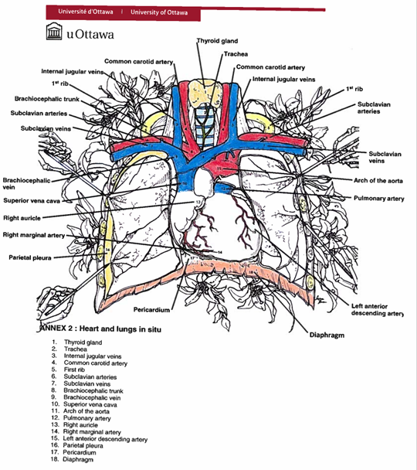
Supplementary material
Appendix 4: Posttest form



Anne󠇯xe 4: posttest (1&2)

Identification :
S’il vous plait répondre aux questions suivant en vous servant de la banque de mot.
Banque de mots
Glande thyroïde Trachée Veines jugulaires internes Artère carotid commune Première côte Artères sous-clavières Veines sous-clavières Tronc brachiocéphalique Veine brachiocéphalique Veine cave supérieure Crosse de l’aorte Artère pulmonaire Oreillette droit Ventricule Gauche Plèvre Péricarde Ventricule Droit Diaphragme
Aorte ascendante Aorte descendante

Questions
1
2
3
4
5
6
7
8
9
10

